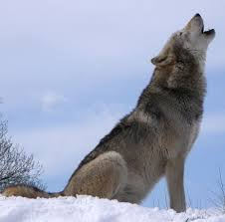
UNIT 4 SPEAKING
- Look at the photo. What animal is it? What is it doing? Imagine this is the cover of a novel. What could the story be about?

- Read the quote. Think of examples of folk tales or legends that didn’t happen, but can tell us something true about life.
‘All stories are true. But some of them never happened.’ James A. Owen
- What do you know about Shakespeare? Why is he famous worldwide?
- How can people stay young-looking today? Would you do it?
- Did you have a favourite story as a child? What was it? Why did you like it?
- Write some notes on two of these topics.
- the last film you saw
- something in today’s news
- the weather
- a sporting event

